Constellation Worksheet

**Add URL for repl it**

<https://replit.com/join/gfbxznaq-lgurung>

Screenshot of Screen 1:

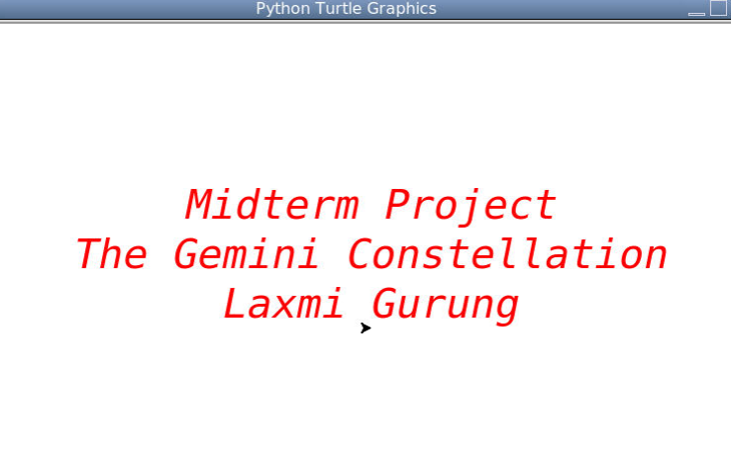

Screenshot of Screen 2:

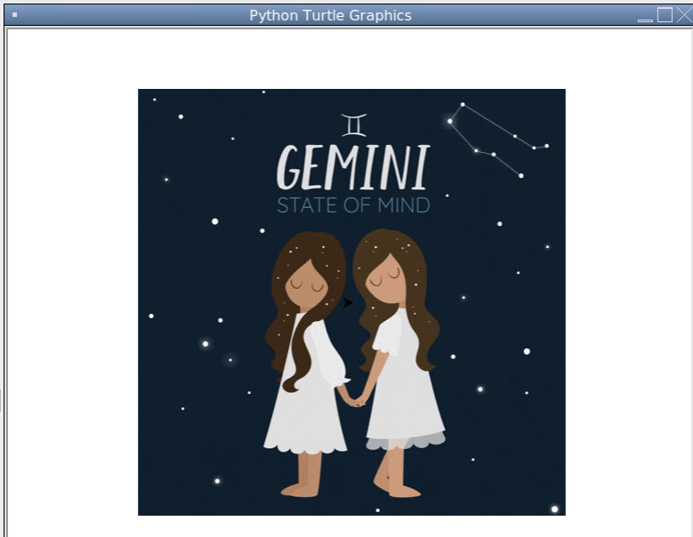

Screenshot of Screen 3:

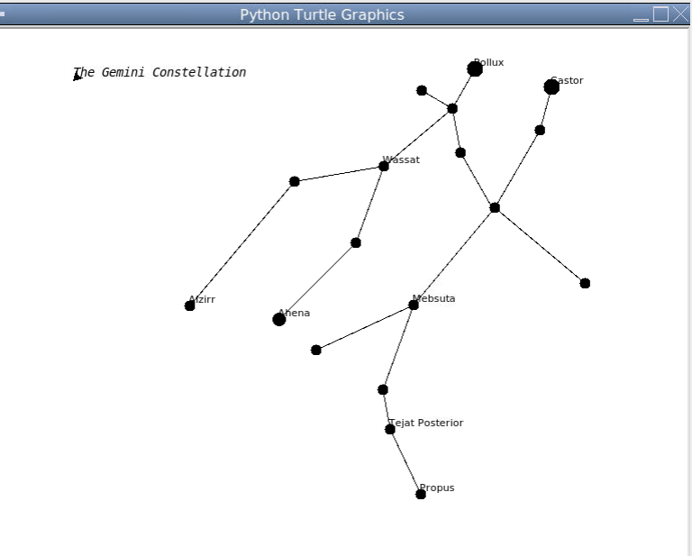Screenshot of Screen 4:

